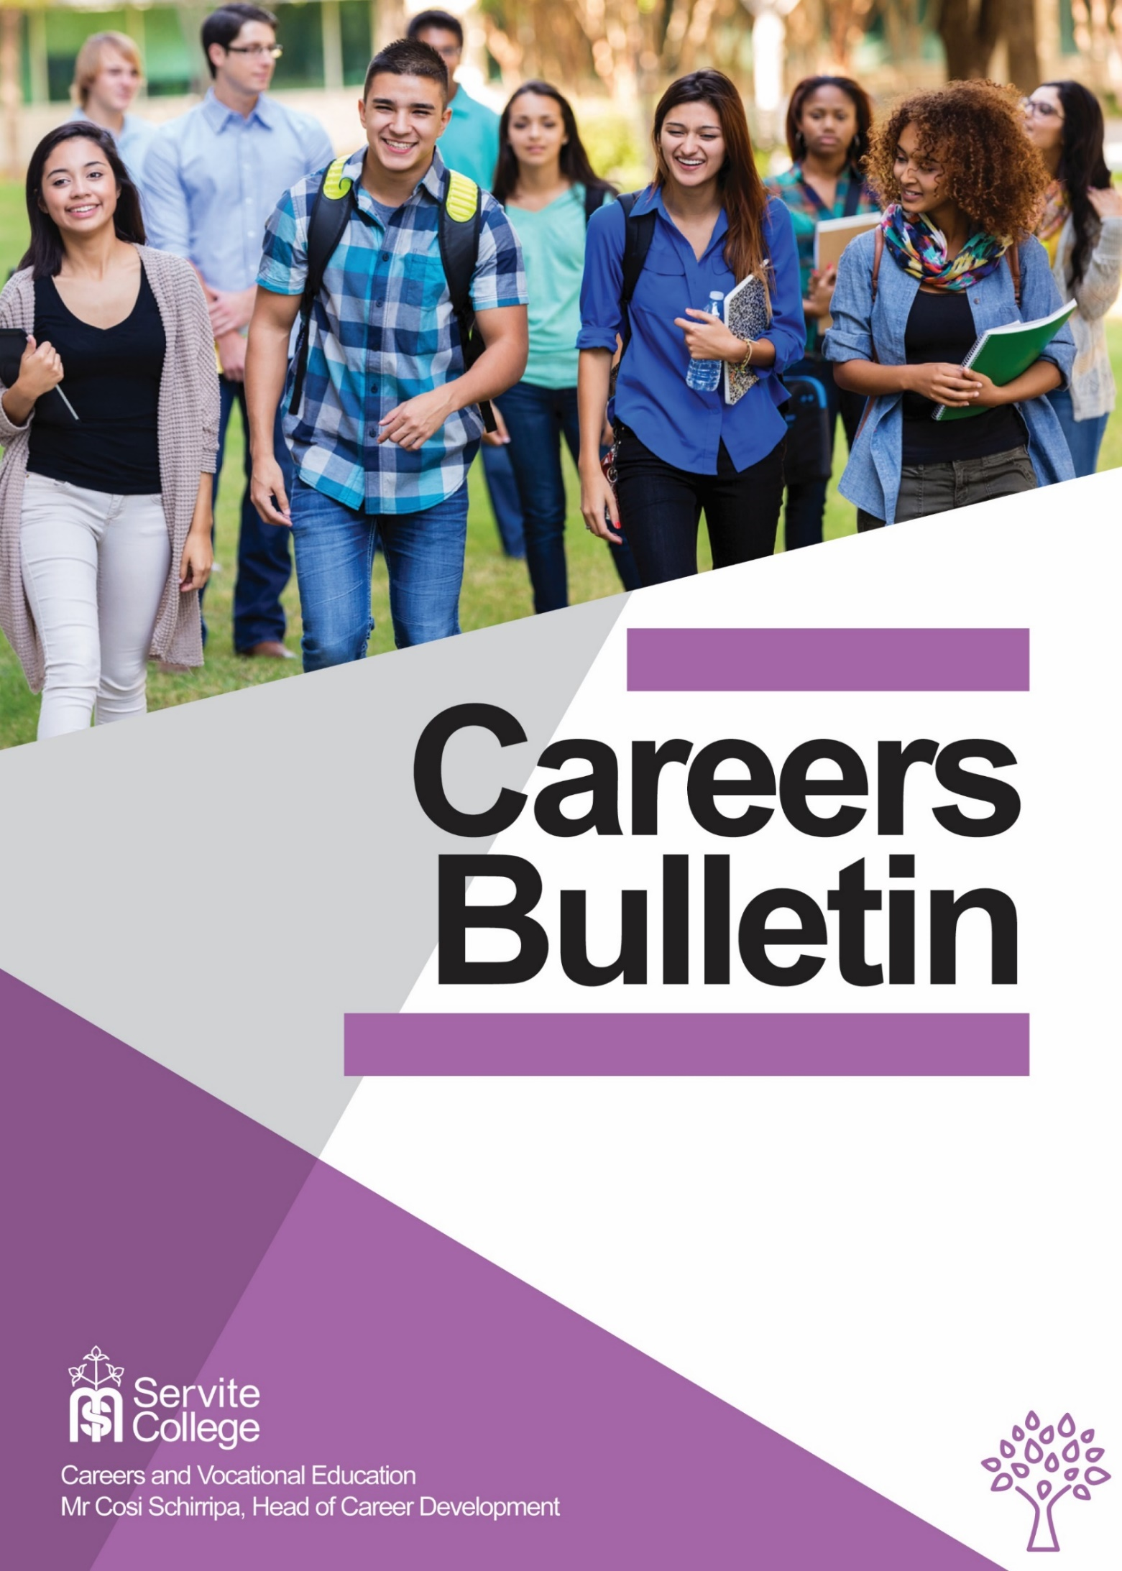
MAY 2019

Section 1: Career News for Students and Families

1 May ECU Pizza Night
Students and parents can unravel the mysteries of university entry, regardless of ATAR.
People with or without an ATAR at the end of Year 12 are invited to attend. Please register to attend below and we'll remind you as the event gets closer

Joondalup Campus 6.00pm - 7.30pm Register HERE.

7 May The Big Day In – The Biggest ICT Careers Day of the Year
The program for this year looks very interesting.
Speakers include:
- New graduates speaking about their journey into ICT
- Cybersecurity experts
- The WiseTech Global talk about their career journey
You can check out the speakers and Exhibitors HERE.
Register to attend HERE.

14 May WAAPA Production Tours
Join in a tour of WAAPA's world-class facilities and venues from 'page to stage' as ECU takes you through the process of producing a show. Visit design and costume studios, check out sound and lighting facilities, and explore ECU’s extensive props and scenery workshops on the way to a Q&A at the Geoff Gibbs Theatre.
To register go HERE.

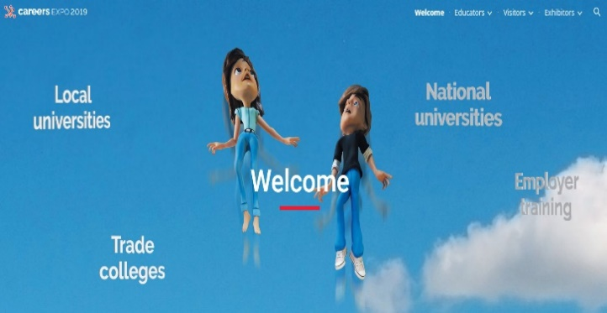
16 – 19 May 2019 Careers Expo
The Careers Expo is the biggest showcase of courses, universities, training providers and support services run in Perth each year.
On Thursday 16th and Friday 17th school groups tend to dominate the crowd. On the weekends families are the ones out in force.
It is on at the Convention Centre. Find out details HERE.

Section 2 – Upcoming Events

2 May Curtin Science and Engineering Information Evening
Join Curtin University personnel for their 2019 Science and Engineering Information Evenings to find out how your aptitude for maths, science and technology could lead to a successful STEM career and prepare you for the global workplace of tomorrow.
Find out more HERE.

8 May Curtin Humanities Twilight Course Expo
Humanities at Curtin includes a broad range of courses:
- Built environment
- Communications
- Creative arts
- Design
- Education
This event will be a great opportunity for you to find out more about Curtin’s courses and speak to their expert staff who will be on-hand throughout the night.
Register HERE.

8 May Notre Dame Information Night
Drop in to explore Notre Dame, enjoy a hot chocolate, chat with academic staff and NDA students, and find out how a Notre Dame education will equip you with the skills to navigate
a future that hasn’t even been dreamt of yet.

Find out more HERE.

8 May Murdoch Social and Cultural Studies
According to Murdoch, their Arts degree can help you to make a real difference to communities around the world.
Murdoch boasts extensive internship opportunities, a new Global Security course and a selection of successful Alumni (past graduates) contacts which will “help you become a skilled communicator and creative thinker”.
Register HERE.

10 May UCAT Concession Scheme Closes at 5pm (AEST)
The UCAT (University Clinical Aptitude Test) has replaced the UMAT for entry into most University medical and dental courses in 2020 and beyond. See below for information on the UCAT.
The UCATANZ concession scheme closes on Friday 10th May at 5pm AEST with no exceptions!
Find information HERE:
- Concession Scheme
- Access Arrangements
If you think you may be eligible apply HERE

14 May Curtin Health Sciences Information Evening
“Make their health your career”. Explore Curtin’s range of courses and discover more about studying one of their health sciences degrees. After the main presentation, you can ask staff one-on-one questions in an expo-style setting while enjoying light refreshments.
Find more information HERE.

17 May UCAT Registrations and Bookings Close 11.59 AEST
Late registrations or bookings are not accepted after this deadline. REGISTER HERE
The UCAT is a 2-hour, computer-based test, multiple choice test. Candidates will sit the test at Pearson VUE test centres located in Australia, New Zealand and some overseas centres. For information about where test centres are offered, see Test Centre Locations on the website. Free official practice materials are also available at the website.

The UCAT ANZ is offered on a choice of dates throughout the month of July, rather than on one single date. You are advised to follow their Twitter and facebook social media channels for updates.

22 May ECU Teacher Eduction Course Information

Find out why the Teaching courses at ECU continue to be so popular and tour the School of Education (Mt Lawley) buildings.
Mount Lawley Campus Register HERE

22 May Murdoch IT Information Night
Studying Information Technology at Murdoch can prepare you to work in the growing technology industry. Tour our new Innovation Hub and discover how our accredited courses will give you the skills you'll need for technology jobs of the future.
Register HERE

General Information
- WA Academy of Performing Arts (WAAPA) Short Courses
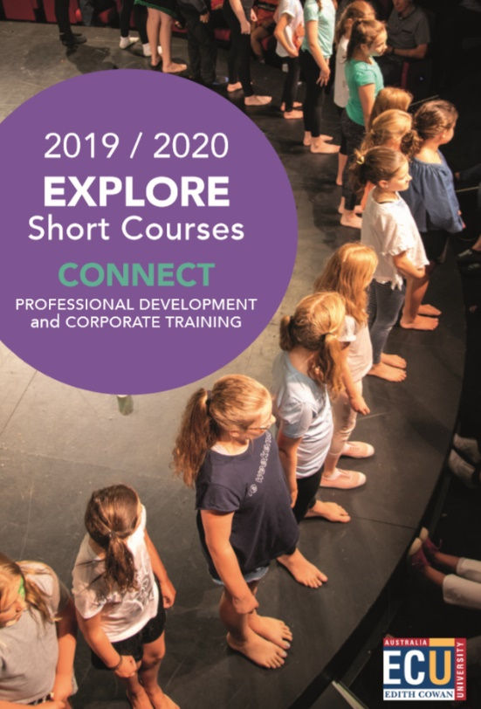
WAAPA runs short courses for school students throughout the year.
The Winter School Holiday Program includes:
- Acting Up 1
- Music Theatre Mid-Year Workshop (Junior)
- Film Making and Screen Performance
- Acting Up 2
- Music Theatre Mid-Year Workshop (Senior)
There are classes starting in May for:
- Acting
- Music
- Music theatre
- Dancing
Some of these programs are linked to WACE courses.
For the 2019/2020 brochure go HERE

Traineeships in the WA Public Sector
To be considered for a traineeship, individuals must:
- be between 17 and 24 years of age
- have completed a minimum of Year 10 or equivalent
- have a current residential address in Western Australia
- be committed to working full time for up to 12 months (or part time for up to 18 months) in an office environment within a public-sector agency.
Interested individuals can receive traineeship job alerts as they are advertised on the WA Government's Jobs Board by registering at ‘Email me jobs’ and selecting Apprenticeship/Traineeship under 'Occupation' when completing their details.

SCSA Student Portal
The SCSA Student Portal is a space for Year 12 students to check and access personal information that relates to their WACE.
You need to have your WA student number – which you can find out through your school – and a password to access the portal STUDENT PORTAL

First in Family Success Strategies
Students who are the First in (their) Family to go to university have got their own site designed to stop them dropping out and to help them get on the path to success.
It has great tips, including a many based on what other students thought school leavers should know.
If you didn’t do as well as you hoped in your first term assignments the First in Family site has Study Hints that may help to get you back on track.
If also has some learning style questionnaires which may help you to streamline your study techniques.

