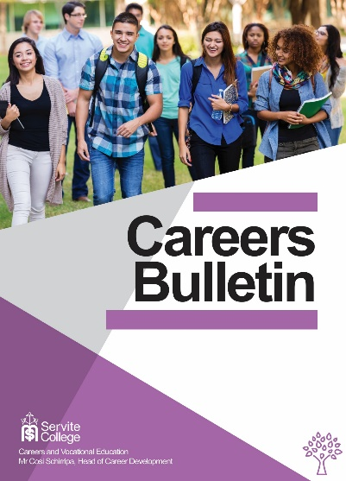

June - 2019

Training News

18 June Rio Tinto Apprenticeship Information Session Thornlie Jobs & Skills
This Rio Apprenticeship information session will provide information about:
- The application process
- Rio Tinto’s Pilbara operations
- Key trade areas
- FIFO lifestyle
- A day in the life of an apprentice
Thornlie Jobs & Skills Centre, South Metropolitan TAFE, Burslem Drive, Thornlie
4pm and 5pm. Register HERE or call us 9267 7600.

June 19 – 21 Getting into Resources Expo at NM TAFE
In June North Metro TAFE is hosting the Getting Into Resources Expo.
It has released Skills to Support the Mining Industry which shows many of the courses that you can do at North Metro that will lead to careers in the Mining Industry.
You can register for the Expo HERE.

22 June College of Electrical Training (CET) Open Day

This event gives an opportunity to find out more about electrical trades, employment opportunities and gaining an electrical apprenticeship pathway at CET.
If you're interested in a career in the electrical industry, don't miss this year's Open Day on 22 June from 9.30am to 1.00pm at both Jandakot and Joondalup campuses.
Register HERE.

Australian Apprenticeship and Traineeship Practice Quizzes

Australian Apprenticeships and Traineeships Information Service’s Practice Aptitude Literacy and Numeracy Quizzes are now online!

Year 12 News
Events

29 May ECU Media, Communications, Arts and Design Twilight Tour
Tour the ECU Arts Hub and experience the fabulous facilities for students in these disciplines.
Mount Lawley Campus 6.00pm - 7.30pm Register HERE.

29 May Curtin Commerce Information Evening
Learn more about Curtin’s Bachelor of Commerce, including the wide range of business specialisations, industry connections, innovative teaching facilities and internship opportunities, by attending our Commerce Information Evening.
Register HERE.

5 June Murdoch Engineering Open Night
Murdoch Engineering has the highest median starting salary in Australia and boasts the $10m Bayer pilot plant which you'll tour on the night. Learn how an Engineering degree can lead to solving problems in the mining industry, controlling pollution in cities or designing life-changing technology.
Register HERE.

6 June ECU Engineering and Technology Showcase Evening
Discover why ECU’s School of Engineering has some of the best facilities in Australia.
Joondalup Campus 6.00pm - 7.30pm Register HERE
- 15 June Endeavour College Open Day
Endeavour College conducts courses in natural health. They are having their annual open day on June 15. You can find more details HERE.

7 – 19 July ATAR Revision Programs
Many year 12s take advantage of ATAR revision programs during July. If you haven’t already enrolled, these are some of the providers in Perth.
These providers also do OLNA and NAPLAN revision programs.
Master Mind Australia intensive revision of the syllabus and assessment preparation, including the effective modelling of answers to ATAR-style exam questions.
Claremont - Guildford Mindarie - Wembley Downs - South Perth
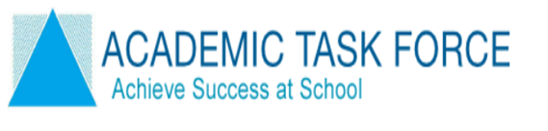 | Academic Task Force specialist teachers work with students showing them how to apply what they have learnt at school, how to prepare for their exams and how to maximise their exam performance.  Rossmoyne SHS - Churchlands SHS- Perth College - Perth Modern School
 | ATARget ATAR Revision, ATAR Exam Preparation and Study Skills programs focus on strengthening students’ understanding of subjects, boosting classroom confidence and improving examination performance.
 | WACE+ ATAR Revision, ATAR Exam Preparation and Study Skills programs focus on strengthening students’ understanding of subjects, boosting classroom confidence and improving examination performance.
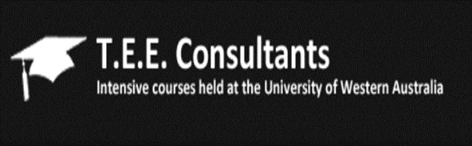 | TEE Consultants deliver intensive courses for year 12 students seeking university.  Courses are run at UWA and Murdoch.
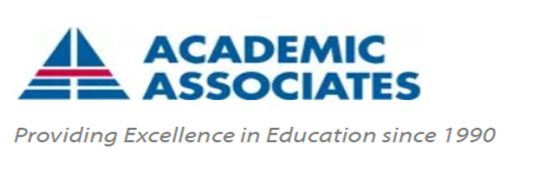 | Academic Associates conducts courses in most WACE subjects. See latest timetable.  Venues: UWA and Notre Dame University
 | InTuition Education Support delivers small group classes in most WACE classes, exam preparation and study skills.
 | Revise Online Those who prefer to revise by themselves or those who live in rural and remote areas my like Revise Online. You can find their range of services HERE.
INDIVIDUAL TUTORS
Many semi-retired teachers continue to tutor in their specialty subject.
These teachers have a lifetime of knowledge of their subject, what examiners are looking for and tips for success.
Ask at your school front office to see if they know anyone you can contact.

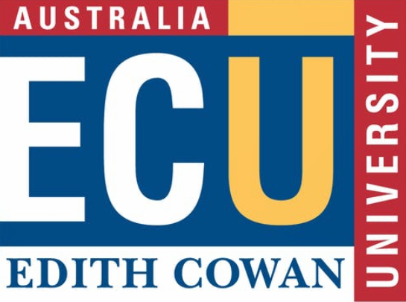 | ECU ATAR revision programs are run from September 30 – October 4 at the Joondalup and Bunbury campuses.  These are a free service to Year 12 students.  Register for Joondalup HERE.  Register for Bunbury HERE.

Opportunities

31 July Notre Dame Early Offer Program Applications due for Semester 1, 2020
Notre Dame's Early Offer Program is open to Year 12 students who have demonstrated academic excellence and/or are making a significant contribution to their school or community.

Most Sought After Employers
Goggle, Apple, Deloitte and CSIRO are among the most sought-after employers as identified by graduates in a 2018/19 survey. Click HERE to see the top 100.
By checking out the Learn More tabs on the site you can find what sorts of jobs companies offer and what skills and attributes they are looking for.
option.

Defence

ADFA Education Awards
The Australian Defence Force Academy Education Award is presented annually to Year 12 students in recognition of leadership potential, and academic and sporting achievements exhibited during Year 11.
This is a prestigious award, awarded to the 120 most suitable applicants who have applied for entry to the Australian Defence Force Academy (ADFA).
To find out more go HERE.

Navy Recruiting
The Priority Growth areas for Navy recruiting at the moment are Communications, IT and Intelligence .
You can check them out plus Navy Gap Year opportunities HERE.

Report from Curtin Careers Teachers’ Information Day

Each year each Western Australian university runs an information day where they give Careers Practitioners and teachers information about new courses, services and opportunities that they offer. This is information is from the Curtin University Big Day Out for Teachers.

Curtin Business and Law Information and Advice
- Students considering going to Curtin in 2020 to undertake business or law degrees are strongly encouraged to attend the Curtin Open Day on 21st July.

- A new Business and Law course information book will be launched at the Open Day. It contains information about new courses and options to increase flexibility in business and law degrees that will begin in 2020.

- Curtin is focusing on supporting students to undertake work integrated learning for credit and they encourage students to do part of their degree overseas.

- There is a strong emphasis on innovation and a partnership is developing between Curtin and Stanford University which is the #1 university for innovation in the world. Graduates from business or law will be able to apply to do an 8 week post graduate intensive program at Stanford University.

Curtin Health Sciences

- There are 24 different courses in the Health Science School at Curtin and there are opportunities to do creative combinations like double majors from some health science courses with business and law degrees.

- Students wishing to design a unique course should go to the Curtin Open Day and speak to staff in the Admissions Team.

- Curtin is changing its Occupational Therapy and Pharmacy courses so that students graduate with an honours degree.

- Curtin has almost doubled the number of Oral Health Therapy places in order to keep up with unmet demand.

- There will be 90 places in the first-year medicine program in 2020. Most places will go to school leavers.

- It is recommended that students develop a Plan B with the support of careers teachers. For example, entry to physiotherapy at Curtin requires a very healthy ATAR. If you are unsuccessful in gaining a place based on your ATAR start another course that will enable you to switch to physio if your grades in this course are competitive.

- Half of all first-year subjects are shared across the Health Sciences School.

Curtin Humanities

- There are 22 possible majors in the Humanities School at Curtin.

- The emphasis is on undertaking a course of study that will lead to employment.

- All students undertaking a teaching degree must pass a Teaching Performance Assessment of literacy and numeracy skills. This is a Federal Government requirement that all undergraduate pre-service teachers must pass.

Curtin Science and Engineering

- The Curtin Science and Engineering School is introducing more flexibility and more digital competency across all courses.

- A Graduate Diploma in Cyber Security is increasing Curtin’s focus in this field.

- An Associate Degree in Agribusiness started this year. Entry to this course is via portfolio and it articulates into a degree in Agribusiness.

- Double degrees are common with 5 year computer science and engineering degrees being most popular.

Applying for Uni through TISC - Curtin Tips
- Make sure you put a personal email address onto your application NOT your school one.

- Be clear about deadlines. It is staggering how many applicants miss deadlines.

- Put your Number One preference FIRST, then your next favourite etc. You will have opportunities to change preferences later.

- If you are going to be overseas or out of range when offers are scheduled, put a proxy, like your parents or trusted family member who can act on your behalf, on your application.

Curtin Scholarship Application Tips

Curtin has a new page where they have gathered all information about scholarships.
There is an 18-page step by step guide to applying for scholarships, starting with how to search for scholarships you are eligible for.
A key tip is to BE AWARE OF CLOSING DATES.
The best scholarships take some time and effort to create a great application.
Curtin collects information about lots of scholarships that are not just related to Curtin courses. To subscribe to updates about scholarships that may interest you go HERE.

Year11 News

Urgent 31 May National Youth Science Forum Applications Close
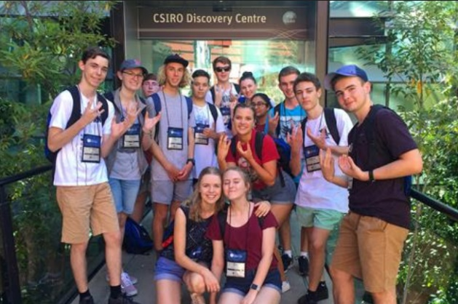
Calling out to all year 11 students. If you like hands-on science workshops, meeting new people and hearing from world-class scientists, apply for the 2020 National Youth Science Forum by 31 May 2019. For more information head over to the NYSF website.
- There are Equity Scholarships that cover about $1000 of the costs.
- See a video gallery of previous camps HERE.

Projects Abroad
Projects Abroad offers a wide range of overseas volunteer and service opportunities for high school students. Whether it’s a group mission trip tailored to the school’s requirements or holiday programmes for individuals or small groups of friends, Projects Abroad arranges practical, educational immersion and service projects over 30 developing countries around the world. For more information go HERE.

Middle School News

. 17-19 June Year 9 & 10: Try a Trade Opportunities@North Metro TAFE
If your Year 9 or Year 10 students have an interest in the Construction industry, they may want to enrol in the Try-A-Trade program. Over three days students will try a bit of bricklaying, tiling, and plastering. The program will run at Clarkson and at Balga. A minimum of 12 students is required. Contact North Metro TAFE for more information.

19 – 21 June Year 10: Getting into Resources Expo for Secondary Schools

This three-day event is designed to showcase the resources industry to secondary schools. It had been primarily developed to assist Year 10 students with making informed decisions about their senior school subject selections.
Students can:
- Learn more about resources careers from people who actually do it every day
- Enjoy hands-on activities providing an immersive and practical experience
- Find out about a range of technical, professional
and trade roles available (both VET and ATAR pathways)
- Interact with people who love what they do in the resources industry
- Make quality contacts for the future
Find out more HERE. Register HERE.
Please note that places are limited so it’s first in best dressed!

ICT Young Explorers Competition
A better way to distil gin, a bushfire early detection system and a car that automatically stops at red lights were among last years national winners of the ICT Young Explorers Competition.

Students can do a project of their choice. Find details HERE

Year 10 and 11 MESH Awards Open Now
Great to see awards available to West Australian creative students.
The MESH at Murdoch Awards recognise and reward year 10 and 11 high school students in for:
- Best Short Film | - Best Persuasive Speech
- Best Video Game Character Concept | - Best Magazine Cover Design
- Best Music Production | - Best Recorded Interview
- Best Photographic Series | - Best Dramatic Monologue to Camera
- Best Online News Story | - Best Short Story

Applications opened in April and close on 18 October. To see a video and get more information about the MESH awards go HERE.

- Year 10 Information on New General Pathway

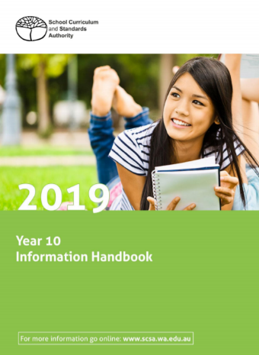
This year the Year 10 Information Handbook delivers information about the new General WA Certificate of Education (WACE) Pathway option that has been added to the ATAR and VET pathways.

Although it will no longer be essential for non ATAR students to take a VET course, several teachers have said that their schools will continue to support VET in Schools as a recommended path to helping students to broaden their WACE education.

The April Vet for Secondary Schools research report shows that the number of students taking VET subjects is increasing.
.

