Careers information for July

University News

University Open Days
The open days are brilliant. They are run from late July to late August. They are a great opportunity to get information on courses, get involved in a range of activities and generally get a feel for student life at that university.
21 July  Curtin | 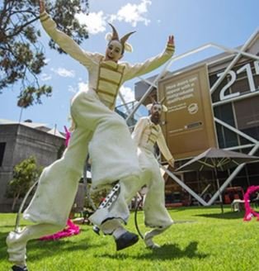  Curtin –  Check out Curtin courses HERE.  Check Open Day Information HERE.
28 July ECU Joondalup  11 August ECU Mt Lawley  25 August ECU South West | ECU  Check out the ECU courses HERE.  Check Open Day Information HERE.  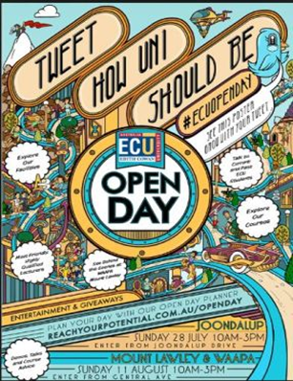
4 August – UWA Open Day Perth and Albany | UWA –  Check out UWA courses HERE.  Check Open Day Information HERE

28 July – Murdoch Open Day Perth and Peel | Murdoch  Check out Murdoch courses HERE.  Check Open Day Information HERE
11 August – Notre Dame Open Day | Notre Dame  Check out Notre Dame courses HERE.  Check Open Day Information HERE.
24 August – CQU Open Day | CQU – Mainly Online with Support Hubs  Check CQU courses HERE.  Check Open Day Information HERE.

First in Family to Go to Uni
Look for the First in Family to Go to Uni booths on each campus. You will get advice and support and told the main barriers you will face as the first person in your family to go to uni.
The First a Family website has information about scholarships, language, study tips and where to get help. For more information go HERE.

University Course Costs
All universities charge about the same for their courses. You get into big differences according to the number of years you study.
Have a good look at the UWA Fees Calculator. It allows you to see courses by area of interest and by individual uni in 2019.
As a rough guide, each unit costs between $800 and $1400 and each year cost ABOUT $9000.
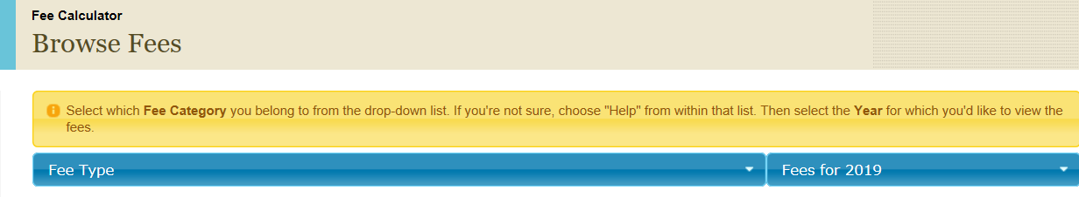
If the course you choose requires you to do 24 units you will be up for roughly $24,000.

Financial Assistance Scholarships
Do you think scholarships are just for the very brightest students?
The Good Universities Guide says:
There are currently more than 3000 scholarships available to Australian students, across both the higher education and vocational sectors. Scholarships can cover an array of costs from tuition fees to living and accommodation costs, our advice is to investigate your options early on as the amount of information to get through and applications to fill can be overwhelming.
Subscribe to the Good Universities Guide Newsletter and type in ‘Support type’ and ‘Field of Study’ filters to narrow your searches as much as possible. Entering key words such as ‘TAFE’ and ‘Vocation’ may also help.

Year 12 News

Scholarships

The following links are to the university scholarship websites where you can find more information.
- Curtain University
- University of Western Australia
- Edith Cowan University
- Murdoch University
- Central Queensland University

Notre Dame Scholarships
Notre Dame has put up details of its undergraduate scholarships:
Academic Merit Scholarships  School of Arts and Sciences  School of Business  School of Education  School of Health Sciences | School of Law  School of Medicine  School of Nursing and Midwifery  School of Philosophy and Theology  School of Physiotherapy

University Events

7 – 19 July ATAR Revision Programs
It seems that most Year 12s tap into at least one ATAR revision session during the July holidays. There are a number of providers of revision programs and each one provides different additional services like OLNA revision or study skills.
Search for ATAR revision programs near you or check the blog post about different services HERE.

8 July UWA Tour
The stunning UWA campus offers a vibrant and dynamic learning environment with its mix of heritage buildings, contemporary architecture and beautiful gardens. Current UWA students will take you on a tour of the campus giving you an insight into what it’s like to be a student at UWA.
Find more information HERE.

9 July ECU Campus Tour Mt Lawley
ECU’s three campuses are great places to learn new skills, meet new people and generally spend some time. Whether you're thinking of studying here, or you're not quite sure, the people at ECU are pretty confident you'll be impressed by the quality of campus and school facilities. Register for the Mt Lawley tour HERE.

10 July ECU Joondalup Campus Tour
Check out the amazing science and engineering projects at the Joondalup Campus. See the new cyber security facilities. The Joondalup Campus is fantastic. Register HERE.

11 July ECU Mt Lawley Information Evening
These information evenings give students and families the opportunity to find out about courses and about the support services available. ECU goes out of its way to make students and their families feel welcome. Register for this information evening HERE.

15 July UWA Individual Advisory Sessions
You don’t need to know what questions to ask to book into an individual advisory session.
These sessions are designed to help you to gain a better understanding of future study at UWA. Bookings are essential due to a limited number of sessions. Book HERE.

17 July Parent Power Hour: Managing Exam Stress
Help support your student's transition from high school to university with the Murdoch University Parent Power Hour.
Exams can be a challenging time for all students. Learn from the experts at Murdoch Counselling Service as they cover some important tips and techniques on how you can support your student in our Managing Exam Stress evening.
Who should attend?
This event is designed for parents and family members of year 11 - 12 students undertaking exams. To register go HERE.

31 July Notre Dame Early Offer Program Applications due for Semester 1, 2020
Notre Dame's Early Offer Program is open to Year 12 students who have demonstrated academic excellence and/or are making a significant contribution to their school or community.

5 August TISC Applications Open

Year 12s often leave it till the last minute to put in their TISC application for uni. This is an intense time in your life. Try to take the pressure off by making an appointment with Mr Schirripa and getting your application in as early as possible.

Year 11 News

19 July 2019 Experience a Day in the Life of a Notre Dame student
A Day in the Life of a Uni Student is an event for Year 10, 11 and 12 students to experience what uni life is like at Notre Dame
Venue: The University of Notre Dame Australia, Prindiville Hall (ND3), Mouat Street, Fremantle.
Time: 9.00am – 2.30pm (Year 12 students are invited to an optional application workshop from 2.30 – 3pm)
Register HERE

