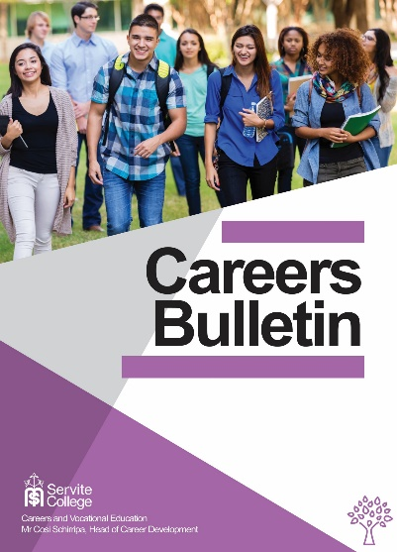

Training and Apprenticeship information - July, 2019

Training News

- 2020 Apprenticeship Application Time
Programmed has information about its apprenticeships for 2020 HERE.
You can find BHP apprenticeships HERE.
There are MANY apprenticeships being advertised. Just search 2020 apprenticeships.

- 21June to 15 July Alcoa Apprenticeship Applications
As an apprentice you will learn on-the-job in a safety conscious environment and, on successful completion of your apprenticeship, receive a nationally recognised trade certificate in one of the following trade categories:
- Mechanical Fitter
- Fabricator / Welder
- Heavy Duty Plant Mechanic
- Industrial Electrical Instrumentation Technician
For more information click here.
- Apply Now for Building Trades Pre-Apprenticeship at Skillshire
This pre-apprenticeship is a Certificate II in Building and Construction.
It starts on 5 August at Skills Hire in Forrestfield. You can email training@skillshire.com.au to get more information.

Australian Apprenticeships and Traineeships Information Services
Finding an Australian Apprenticeship will be tough this year as the number of jobs available continues to fall.
It is the AAPathways job to make it easier to find out about apprenticeships and traineeships. The website has a range of helpful resources that can be used to help career research.
There is also the AusAppPathways mobile application, and the My Gain YouTube channel which has videos of apprentices and what they think of the work they do.
How to Blitz Your Apprenticeship Interview has tips that can help you to land the job.

Women in Trades
The National Energy Technician Training Scheme (NETTS) has 38% female apprentices in their program. If you are interested you can find more information HERE.
Tradeswomen Australia provides information and support to women going into non-
traditional trades.

Are You Ready for a Pre Apprenticeship or Apprenticeship?
You can check to see if you have the literacy and employability skills needed to get an apprenticeship or pre apprenticeship by doing these quizzes. If you are not yet ready you may be able to do a Foundations Skills Program which will help you to get ready.

Scholarships for Enrolled Nurses
The Nursing and Midwifery Office has a range of scholarships for nursing and midwifery students studying in Western Australia. The scholarships can help you:
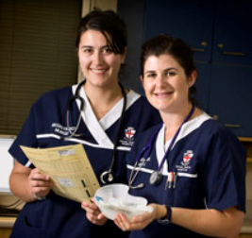
- become a nurse or midwife
- to progress your career.
Scholarships are awarded, based on current and projected workforce requirements and for areas of high clinical need. Priority is given to WA Health employees.Applicants for this scholarship should be studying a Diploma of Nursing (Enrolled/Division 2 Nursing). For more information go HERE.

