October 2019

Training News

Events

1. Applications Now Open for TAFE 2020
If you need help or advice re TAFE and other Training courses after you leave Servite the Jobs & Skills Centres can assist school leavers in applying for 2020 programs at TAFE or anywhere else.
- 2 September Applications Opened for Semester 1 2020 TAFE courses
- 6 December Applications close for competitive courses
- 9 January Offers Made
- 13 January Applications Close for non-competitive courses.

ROUND 2 APPLICATIONS
- 7 January 2020 Where vacancies exist after Round 1 offer and acceptances, Round 2 applications will be considered. You can apply for Round 2 up until 7 January.
- 21 January 2020 Round 2 Offers made
LATE ENROLMENTS
Where vacancies exist after the standard application process, late applications will be considered. Late enrolments are sometimes accepted as late as February where student numbers are down.

Go to your local TAFE College for details:
- North Metro TAFE
- South Metro TAFE
- North Regional TAFE
- South Regional TAFE
- Central Regional TAFE

1 October - Construction Futures Open Day

Discover building design tools and construction management jobs, do the career quizzes, try the virtual reality cranes to pick up a load and see how easy it is to drop it!!!
Check out some of the jobs in the industry HERE.
The Construction Futures Centre in Belmont, Open Day is a must if you would like to know just how varied construction jobs can be.
It takes a couple of hours to do a tour. Sessions start at 9 am and 11 am. It is free, but you need to register by emailing: cfc@ctf.wa.gov.au

1 & 7 October Electrotechnology Pre-Apprenticeship

The College of Electrical Training’s Certificate II in Electrotechnology Pre-Apprenticeship 16-week course starts on 1 October, CET Joondalup and 7 October, CET Jandakot
Register your interest HERE.

7 October 2 Week Bricklaying Labourers’ Course at NM TAFE
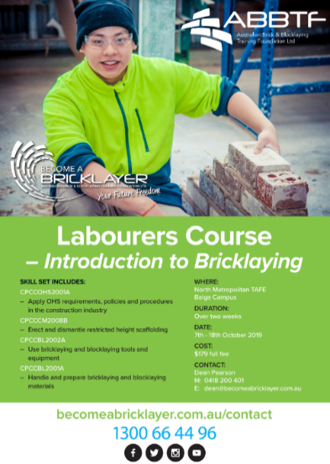
This course is designed to assist people interested in entering the Construction Industry as a Labourer, who are primarily looking for an alternative training pathway and or immediate employment.
The course will cover Basic Bricklaying Support Techniques, delivered by current Bricklaying Lecturers.

Contact Dean Pearson on Dean@becomeabricklayer.com.au

Payments to help you while you study or complete an Australian Apprenticeship

The Australian government gives eligible students, trainees and Australian Apprentices financial help with everyday costs of living and some study expenses.
This intro to student payments video will give you an overview of what is on offer.
Transcript | Watch on YouTube

Where to find cheaper courses
The State priority occupation list (SPOL) identifies where there are skills shortages in WA. The SPOL guides training subsidies that reduce the costs of courses in those occupations.

Grain and pasture growers, sheep farmers, dairy and beef cattle farmers, HR and ICT project managers are among the Level 2 priorities identified in 2019.

In 2020 these courses will be prioritised for additional funding by the government so that costs for these courses go down and are more attractive to potential students.
To check out the 2019 priorities go HERE.

The 2019 SPOL is now available on the Department of Training and Workforce Development website.

University News

30 September TISC Early Bird Applications Deadline
This is the on-time closing date for university applications for entry into most courses in 2020 . You can still apply after this date but will have to an additional application fee. Some courses cannot be applied for after this date
For more information go HERE.

ECU Campus Tours

- 2 October Mount Lawley
- 9 October Joondalup
Register HERE.

15 October WAAPA Tour

Join representatives on this insightful tour of WAAPA's world-class facilities and venues from 'page to stage' and be taken through the process of producing a show. Visit design and costume studios, check out sound and lighting facilities and explore WAAPA’s extensive props and scenery workshops on the way to a Q&A at the Geoff Gibbs Theatre
6.00pm - 7.30pm Mount Lawley Campus
Register HERE.

17 October ECU Engineering and Technology Showcase

These sessions include a tour of the school’s facilities and the opportunity to meet the academic staff.
This Information Session will introduce you to courses and the excellent support services you can expect as a student at ECU. The session will cover admission pathways, how to apply, fees and scholarships, and flexible study options such as online or part-time.
Joondalup Campus - Register HERE.

Early Offers for 2020 – ECU, CURTIN, UWA & MURDOCH
WARNING: These early offers are NOT like the unconditional University of Notre Dame early offers that have existed for a number of years .
Curtin, UWA, Murdoch and ECU have announced that 2019 Year 12 students can apply to get an early offer of a place in a range of courses for 2020, prior to the final WACE exams.
However these offers are “Conditional Offers”. This means applicants must still:
- Apply through the normal TISC process.
- Achieve the ATAR minimum selection rank.
- Meet English Language Competency
- Meet all course pre-requisites.
There has been some discussion that students who are familiar with the Notre Dame early offer process may relax when they receive an offer from a one of these public universities and not study hard enough to achieve the ATAR score they require.
REMEMBER THESE OFFERS ARE CONDITIONAL

Curtin Uni Information Students Year 10 – 12

Check out this video and the information about subject choice, life at university and what to expect HERE.

ECU Peer Mentor Services

ECU Peer Mentor Services assist new students in building social and academic networks, so they settle more quickly into life as a student and have a more successful, productive and positive personal and academic experience by linking first-year students with more experienced students in their course or study area.
ECU also has support for new and existing students including:

- Free Learning Advisors to assist with developing your study skills.

- ECU Careers & Employability Services provides free, professional career counselling and job search support. They'll help you find employment and work experience opportunities while studying, as well as plan your transition from uni to working life.

- The Student Guild is run by ECU students and provides academic, social and financial assistance, organizes events, supports student clubs, and offers member discounts and has second-hand books for sale.

- ECU Health Centre and Counselling Service for students.

For more information about Peer Mentor Services go HERE.

Year 12 News

30 September – 4 October ECU ATAR Revision Joondalup

ECU offers ATAR Revision Sessions as a free service to Year 12 high school students.
While they are very popular you may still be able to find a place (or a cancellation) for some sessions.

Register HERE.

4 October Portfolio Preparation Day

Murdoch’s free Portfolio Preparation Day will give you the skills to build a portfolio to gain entry to the creative media or communication course you're most passionate about.

WHO SHOULD ATTEND?
This event is designed for students intending to apply to Murdoch University using a creative portfolio.
Find out more about Murdoch’s Media Portfolio Award admission pathway.
Read more Register HERE.

Alternatives to Medicine at Curtin

Curtin has the only Bachelor of Medicine you can enter straight from school in WA. Not everyone is going to get in so Check out the alternatives which may lead you to an even better career. There are 831 listed!!

Need a Job When You Finish School? Boot Camp to Employment

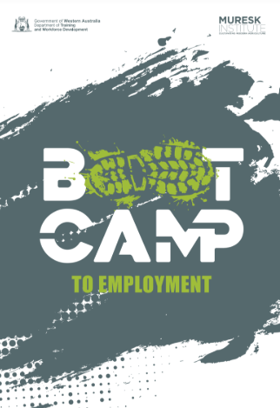
The 3-day WA Farmers Boot Camp to Employment is being run early in 2020 at Muresk College.
From doing the course you will learn:
- To operate precision control technology,
- Machinery application for agronomy,
- Data based decision making.
You will also meet employers looking to employ apprentices and trainees.

For more information contact Prue Jenkins at Muresk on 9690 1556 or Prue.Jenkins@dtwd.wa.gov.au

Study Assist

StudyAssist provides information for students about Australian Government help for tertiary study, including information about subsidised fees and government loans. The website also has information about VET Student Loans.

Year 11 News

8 October Year 10 – 11 A Day at UWA
Do you want to know what it is like to be a student at UWA?

The ‘A Day at UWA' event gives you the opportunity to participate in workshops, meet current students and staff as well as explore the different degrees within the university.

To register go HERE

24 October Women in Technology Conference: IF YOU CAN SEE HER, YOU CAN BE HER!

Women in Technology Western Australia works to broaden opportunities for women to succeed in IT.
This conference looks fabulous with inspiring role models and opportunities to engage with industry.
This is NOT a free event however students are eligible for a discounted ticket. For details go HERE.

Year 10 and Middle School News

1 October Year 9 A Day at UWA

By participating in this event, you will:
- Discover the different degrees at UWA
- Participate in degree related workshops to gain practical experience
- Meet current UWA students
Register HERE

2 or 3 October Murdoch - A Day in the Life of a Uni Student
Target Audience: Year 9 and 10

Join Murdoch for the day and create your own customised university timetable of activities with hands-on workshops in subject areas that interest you.

Speak with current Murdoch students, learn from talented and inspiring academics and make new friends.

There is a wide variety of workshops on offer, including:
- Biomedical Science | - Business | - History
- Criminology | - Engineering | - English & Drama
- Environmental Science | - Forensics | - Games Art & Design
- Graphic Design | - Health | - Law
- Information Technology | - Chiropractic Science (available on Thurs 3/10 only) | - Nursing (available on Wed 2/10 only)
- Physics | - Screen Production | - Sport Science
- Sustainable Development | - Veterinary & Animal Science

8 October A Year 10 and 11 Day at UWA

The ‘A Day at UWA' event gives you the opportunity to participate in workshops, meet current students and staff as well as explore the different degrees within the university.
Register HERE

Defence News

31 October Applications Close for Scholarships for Children and Grandchildren of Veterans
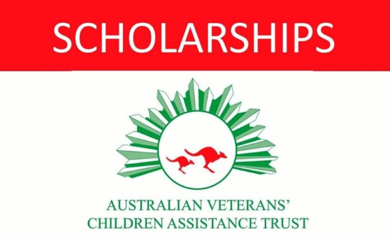
The Australian Veterans Children Assistance Trust (AVCAT) is a national independent charity helping the children and grandchildren of ex-service Veterans with the cost of tertiary education.

Applications for the 2019 Long Tan Bursary and sponsored scholarships of up to $12 000, managed by AVCAT, open on 18 August 2018.
You can contact AVCAT at avcat@dva.gov.au or on 02 9213 7999. The AVCAT website is at www.avcat.org.au

